Problem Statement:

(TinkerCad) The studio uses a combination of 2 lights – Yellow and White, which are to be controlled individually depending on the light outside. The lights are further needed to be controlled and a balance has to be made between yellow and white light.

Solution:

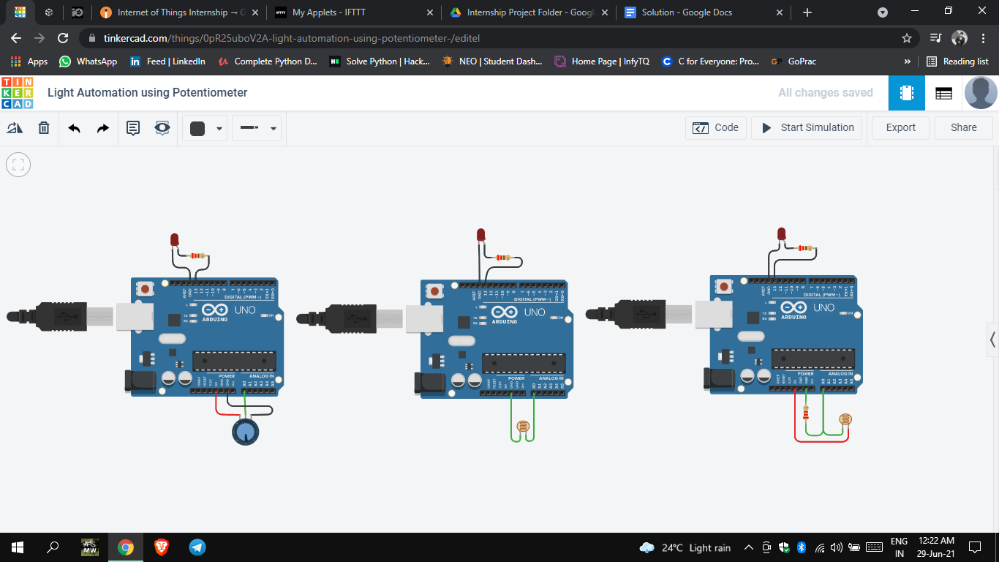

Note: The actual code for the problem was not discussed by the tutor in the videos.